**Profit-Maximized Collaborative in Distributed Cloud and Edge Computing Systems**

**ABSTRACT**:

Edge computing is a new architecture to provide computing, storage, and networking resources for achieving the Internet of Things. It brings computation to the network edge in close proximity to users. However, nodes in the edge have limited energy and resources. Completely running tasks in the edge may cause poor performance. Cloud data centers (CDCs) have rich resources for executing tasks, but they are located in places far away from users. CDCs lead to long transmission delays and large financial costs for utilizing resources. Therefore, it is essential to smartly offload users’ tasks between a CDC layer and an edge computing layer. This work proposes a cloud and edge computing system, which has a terminal layer, edge computing layer, and CDC layer. Based on it, this work designs a profit-maximized collaborative computation offloading and resource allocation algorithm to maximize the profit of systems and guarantee that response time limits of tasks are strictly met. In each time slot, this work jointly considers CPU, memory, and bandwidth resources, load balance of all heterogeneous nodes in the edge layer, maximum amount of energy, maximum number of servers, and task queue stability in the CDC layer. Considering the abovementioned factors, a single objective constrained optimization problem is formulated and solved by a proposed simulated-annealing-based migrating birds optimization procedure to obtain a close-to-optimal solution. The proposed method achieves joint optimization of computation offloading between CDC and edge, and resource allocation in CDC. Realistic data-based simulation results demonstrate that it realizes higher profit than its peers.

|  |  |
| --- | --- |
| **EXSISTING SYSTEM** | **PROPOSED SYSTEM** |
| * Thus, it is critically important to rationally schedule all tasks between CDC and edge computing layers and maximize the profit of distributed cloud and edge computing systems while ensuring that user-specific response time limits of tasks are well met. * It brings computation to the network edge in close proximity to users. However, nodes in the edge have limited energy and resources. Completely running tasks in the edge may cause poor performance. | * This work proposes a cloud and edge computing system, which has a terminal layer, edge computing layer, and CDC layer. Based on it, this work designs a profit-maximized collaborative computation offloading and resource allocation algorithm to maximize the profit of systems and guarantee that response time limits of tasks are strictly met. * In each time slot, this work jointly considers CPU, memory, and bandwidth resources, load balance of all heterogeneous nodes in the edge layer, maximum amount of energy, maximum number of servers, and task queue stability in the CDC layer. * Considering the abovementioned factors, a single objective constrained optimization problem is formulated and solved by a proposed simulated-annealing-based migrating birds optimization procedure to obtain a close-to-optimal solution. * The proposed method achieves joint optimization of computation offloading between CDC and edge, and resource allocation in CDC. Realistic data-based simulation results demonstrate that it realizes higher profit than its peers. |
| **EXISTING ALGORITHM**  Cloud Resource Allocation Algorithm (CRA) | **PROPOSED ALGORITHM: -**Simulated Annealing-based Migrating Birds Optimization (SMBO) |
| **ALGORITHM DEFINITION: -**  This work considers the joint optimization of computation offloading between Cloud data center (CDC) and edge computing layers, and resource allocation in CDC. It is important to maximize the profit of distributed cloud and edge computing systems by optimally scheduling all tasks between them given user-specific response time limits of tasks. | **ALGORITHM DEFINITION: -**  This work evaluates the proposed SMBO with real-life data. SMBO is implemented with MATLAB 2017 in a computer with an Intel Xeon CPU with 2.4 GHz and a 32-GB memory.  In this presents the details of Simulated annealing- based Migrating Birds Optimization (SMBO) to efficiently solve it. |
| **DRAWBACKS: -**   * Less security. * It is challenging to execute them in nodes in the edge computing layer because their computation resources and battery capacities are often constrained and heterogeneous. | **ADVANTAGES: -**   * We prove the security of our scheme. * Improve more resources and battery capacities. * Our scheme has good efficiency. * Optimize computation offloading and resource allocation for nodes in the edge and servers in CDC. |

**System Agriculture**

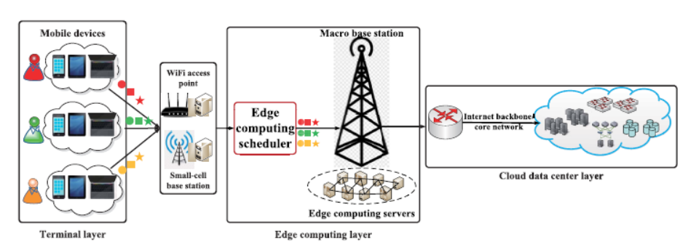

**Illustrative System Framework**

**SYSTEM REQUIREMENTS:**

**HARDWARE REQUIREMENTS**:

System : Pentium i3 Processor

Hard Disk : 500 GB.

Monitor : 15’’ LED

Input Devices : Keyboard, Mouse

RAM : 2 GB

**SOFTWARE REQUIREMENTS:**

Operating system : Windows 10.

Coding Language : Java.

Tool : Eclipse

Database : MYSQL